Pedal for Charity in aid of
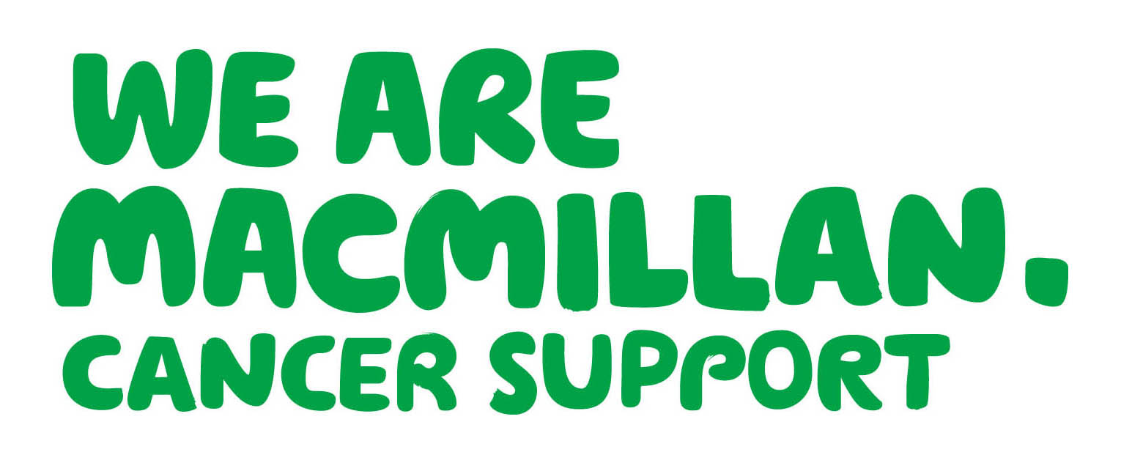
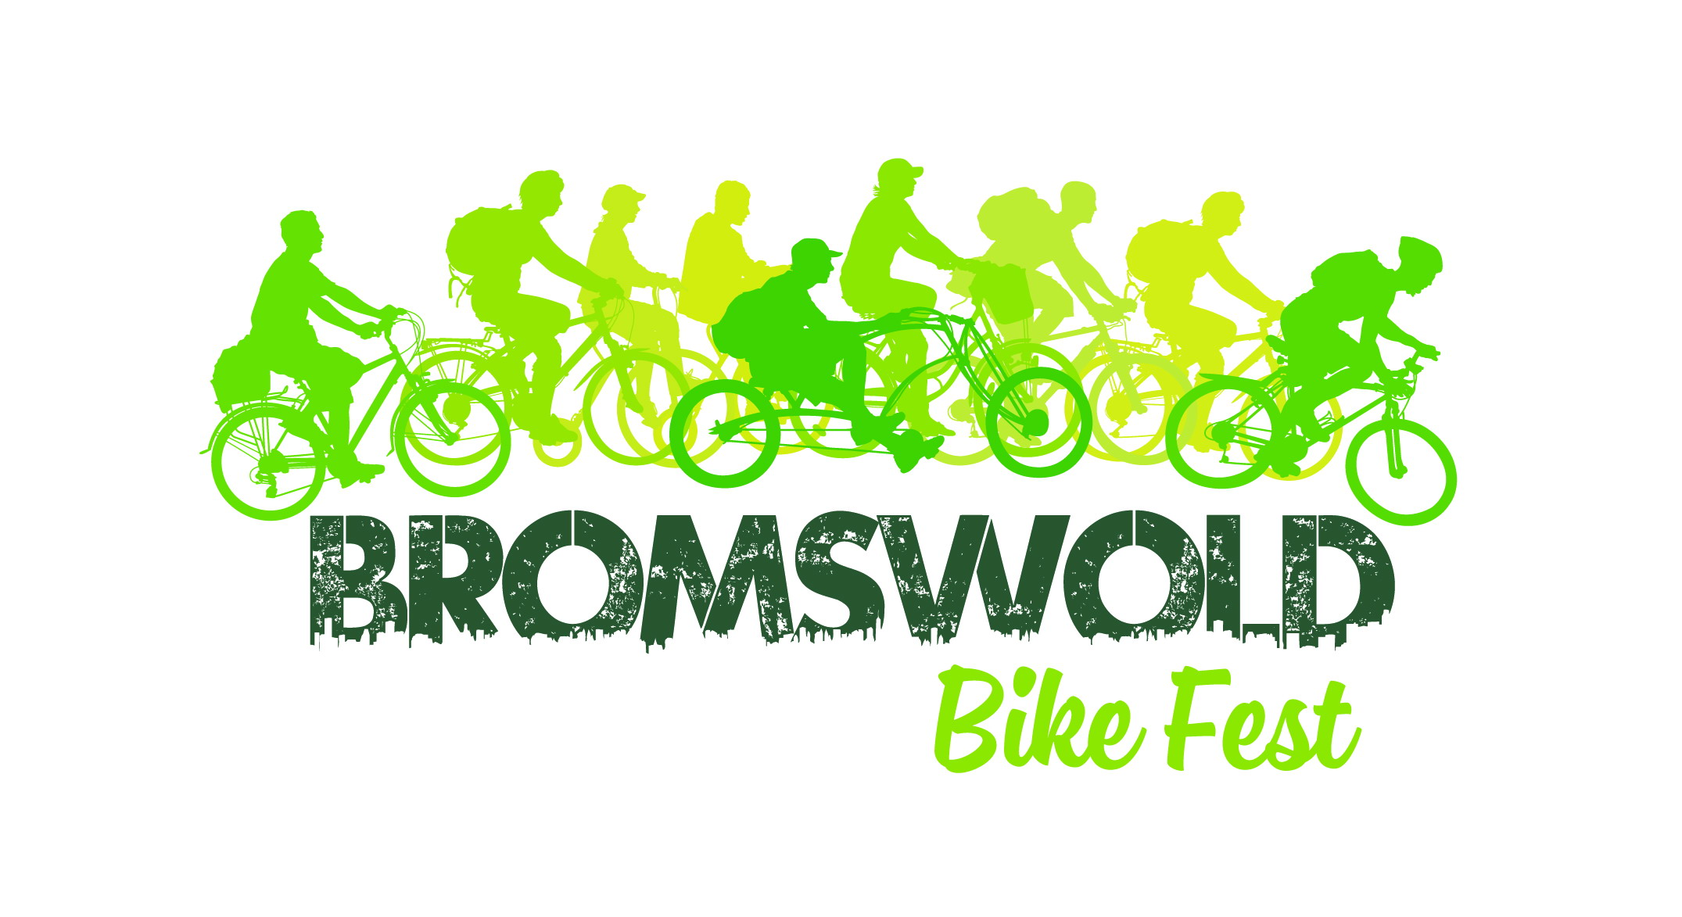
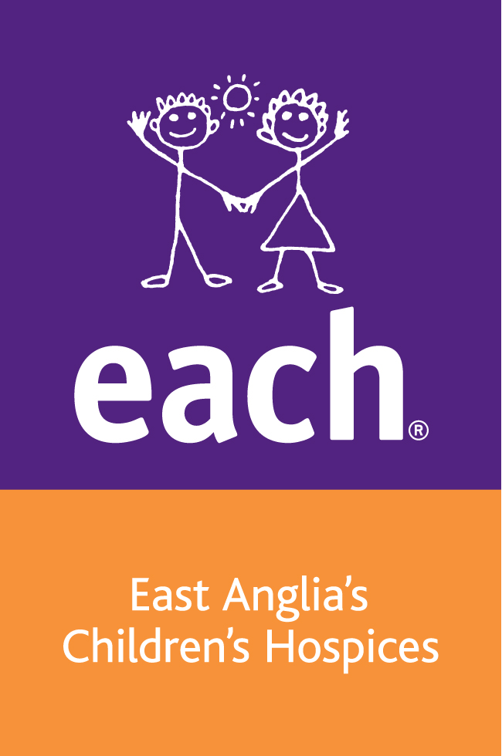
Macmillan and Shine

SPONSOR FORM
PLEASE COMPLETE IN BLOCK CAPITALS

Event name Bromswold Bike Fest 2017 Event date 10 June 2017
Name Date of Birth
Address
Postcode
Gift Aid: Do you pay tax? If so, by simply completing this form you can boost the value of your gift by 25p for every £1 without costing you a penny.
I am a UK taxpayer and I would like Macmillan Cancer Support and Shine to treat all donations I have made for the four years prior to this year and all donations I make in the future as Gift Aid donations until I notify you otherwise. I confirm I have paid or will pay an amount of Income Tax and/or Capital Gains Tax for each tax year (6 April to 5 April) that is at least equal to the amount of tax that all the charities that I donate to will reclaim on my gifts for that tax year. I understand that other taxes such as VAT and Council Tax do not qualify. I understand that the charities will reclaim 25p of tax for every £1 that I give.

Your Gift Aid donation will NOT be valid unless your form is filled out correctly:
- Complete details individually NOT in the same handwriting.
- Fill out your FULL NAME. Fill out your Home Address.

Full name of sponsor | House no/ name (home) | Postcode | Gift Aid (tick) | Amount paid | Date
 |  |  |  | £
 |  |  |  | £
 |  |  |  | £
 |  |  |  | £
 |  |  |  | £
 |  |  |  | £
 |  |  |  | £
 |  |  |  | £
 |  |  |  | £
 |  |  |  | £
 |  |  |  | £
 |  |  |  | £
 |  |  |  | £
Sub total |  |  |  | £

Macmillan Cancer Support, registered charity in England and Wales (261017). A company limited by guarantee. Registered company in England and Wales (2400969) and the Isle of Man (4694F). Registered office: 89 Albert Embankment, London SE1 7UQ
Shine is a Registered Charity No: 249338 | Registered in London no. 877990
PLEASE COMPLETE IN BLOCK CAPITALS

Gift Aid: Do you pay tax? If so, by simply completing this form you can boost the value of your gift by 25p for every £1 without costing you a penny.
I am a UK taxpayer and I would like Macmillan Cancer Support and Shine to treat all donations I have made for the four years prior to this year and all donations I make in the future as Gift Aid donations until I notify you otherwise. I confirm I have paid or will pay an amount of Income Tax and/or Capital Gains Tax for each tax year (6 April to 5 April) that is at least equal to the amount of tax that all the charities that I donate to will reclaim on my gifts for that tax year. I understand that other taxes such as VAT and Council Tax do not qualify. I understand that the charities will reclaim 25p of tax for every £1 that I give.

Full name of sponsor | House no/ name (home) | Postcode | Gift Aid (tick) | Amount paid | Date
 |  |  |  | £
 |  |  |  | £
 |  |  |  | £
 |  |  |  | £
 |  |  |  | £
 |  |  |  | £
 |  |  |  | £
 |  |  |  | £
 |  |  |  | £
 |  |  |  | £
 |  |  |  | £
Sub total (this side) |  |  |  | £
Sub total (other side)
Total
Date paid to charity (via Bromswold Bike Fest)

Macmillan Cancer Support, registered charity in England and Wales (261017). A company limited by guarantee. Registered company in England and Wales (2400969) and the Isle of Man (4694F). Registered office: 89 Albert Embankment, London SE1 7UQ
Shine is a Registered Charity No: 249338 | Registered in London no. 877990

