Pedal for Charity in aid of
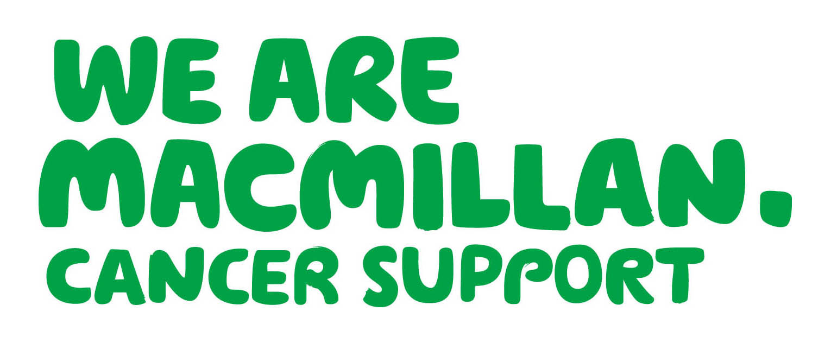
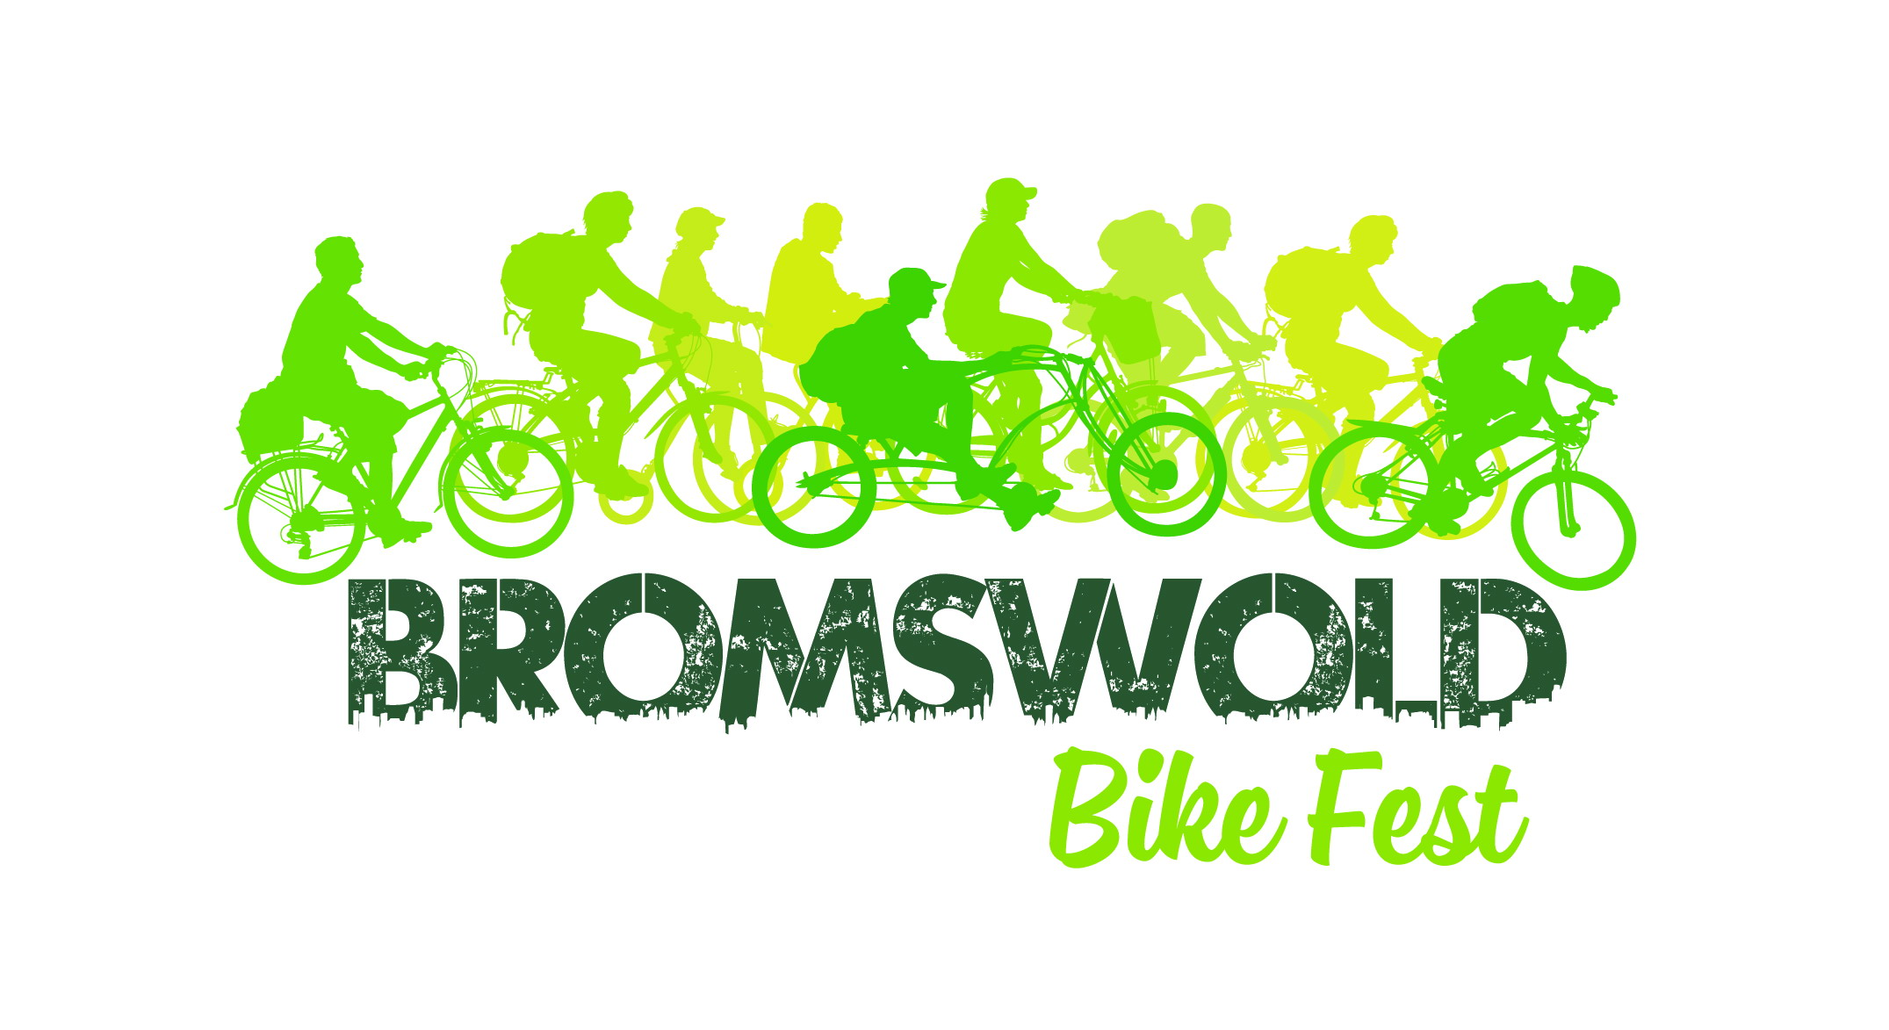
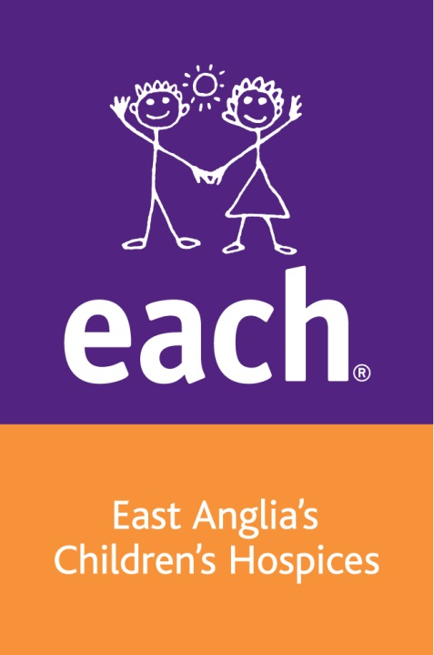
Macmillan and EACH

SPONSOR FORM
PLEASE COMPLETE IN BLOCK CAPITALS

Event name Bromswold Bike Fest Event date __
Name Date of Birth
Address
Postcode
Gift Aid: Do you pay tax? If so, by simply completing this form you can boost the value of your gift by 25p for every £1 without costing you a penny.
I am a UK taxpayer and I would like Macmillan Cancer Support and Shine to treat all donations I have made for the four years prior to this year and all donations I make in the future as Gift Aid donations until I notify you otherwise. I confirm I have paid or will pay an amount of Income Tax and/or Capital Gains Tax for each tax year (6 April to 5 April) that is at least equal to the amount of tax that all the charities that I donate to will reclaim on my gifts for that tax year. I understand that other taxes such as VAT and Council Tax do not qualify. I understand that the charities will reclaim 25p of tax for every £1 that I give.

Your Gift Aid donation will NOT be valid unless your form is filled out correctly:
- Complete details individually NOT in the same handwriting.
- Fill out your FULL NAME. Fill out your Home Address.

Full name of sponsor | House no/ name (home) | Postcode | Gift Aid (tick) | Amount paid | Date
 |  |  |  | £
 |  |  |  | £
 |  |  |  | £
 |  |  |  | £
 |  |  |  | £
 |  |  |  | £
 |  |  |  | £
 |  |  |  | £
 |  |  |  | £
 |  |  |  | £
 |  |  |  | £
 |  |  |  | £
 |  |  |  | £
Sub total |  |  |  | £

Macmillan Cancer Support, registered charity in England and Wales (261017). A company limited by guarantee. Registered company in England and Wales (2400969) and the Isle of Man (4694F). Registered office: 89 Albert Embankment, London SE1 7UQ
Shine is a Registered Charity No: 249338 | Registered in London no. 877990
PLEASE COMPLETE IN BLOCK CAPITALS

Gift Aid: Do you pay tax? If so, by simply completing this form you can boost the value of your gift by 25p for every £1 without costing you a penny.
I am a UK taxpayer and I would like Macmillan Cancer Support and Shine to treat all donations I have made for the four years prior to this year and all donations I make in the future as Gift Aid donations until I notify you otherwise. I confirm I have paid or will pay an amount of Income Tax and/or Capital Gains Tax for each tax year (6 April to 5 April) that is at least equal to the amount of tax that all the charities that I donate to will reclaim on my gifts for that tax year. I understand that other taxes such as VAT and Council Tax do not qualify. I understand that the charities will reclaim 25p of tax for every £1 that I give.

Full name of sponsor | House no/ name (home) | Postcode | Gift Aid (tick) | Amount paid | Date
 |  |  |  | £
 |  |  |  | £
 |  |  |  | £
 |  |  |  | £
 |  |  |  | £
 |  |  |  | £
 |  |  |  | £
 |  |  |  | £
 |  |  |  | £
 |  |  |  | £
 |  |  |  | £
Sub total (this side) |  |  |  | £
Sub total (other side)
Total
Date paid to charity (via Bromswold Bike Fest)

Macmillan Cancer Support, registered charity in England and Wales (261017). A company limited by guarantee. Registered company in England and Wales (2400969) and the Isle of Man (4694F). Registered office: 89 Albert Embankment, London SE1 7UQ
Shine is a Registered Charity No: 249338 | Registered in London no. 877990

